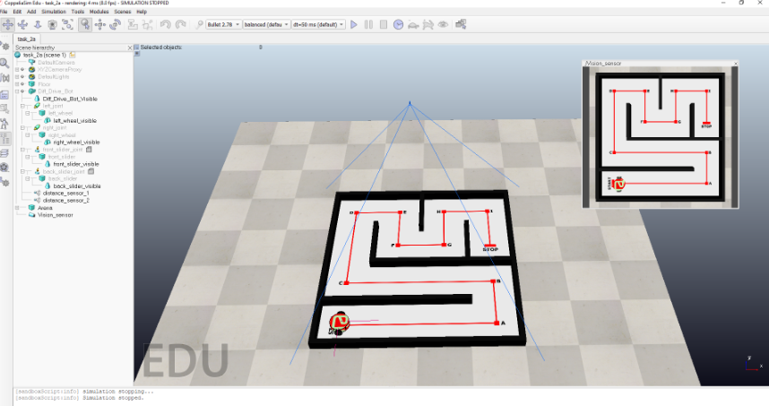

* The scene has the following major elements:
  + **Arena** - The arena for this task
    - **Arena_Wall_1** to **Arena_Wall_9** - Walls act as a guide for the robot to traverse the path
  + **Diff_Drive_Bot** - Differential Drive robot with 2 independently rotating wheels
    - **distance_sensor_1** - proximity sensor 1 mounted on top of robot
    - **distance_sensor_2** - proximity sensor 2 mounted on top of robot
    - **left_joint** - revolute joint connected to the left wheel of the robot
    - **right_joint** - revolute joint connected to the right wheel of the robot
  + **Path** - Red path with 10 target points to be traversed by the robot.
    - **START** - The robot starts traversal at this location
    - **Target points A-I** - The robot needs to traverse these target points in sequence.
    - **STOP** - Final target point for the robot to end traversal
* It is recommended to study the **scene hierarchy** to understand the robot structure.

**Note**: You are allowed to change the position of **distance_sensor_1** and **distance_sensor_2** mounted on top of the robot in order to complete this task. However, the parent-child relationship between robots and distance_sensors should not be changed.  
Apart from this, you are ***NOT allowed to modify*** the scene file in any way (including renaming elements in the scene). Doing so will result in a zero score.

* The objective of this task is to make the robot traverse 10 target points on the red path in the given order **A-B-C-D-E-F-G-H-I-STOP** (shown in Figure 2) where A, B, C, and D are the 4 corners of the red square. Radial **tolerance of 0.1m** is accepted.